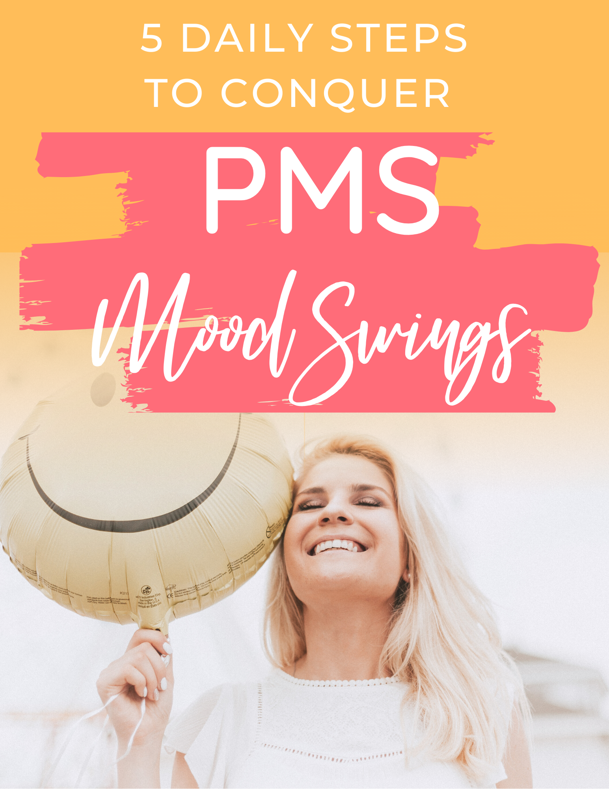
5 Daily Steps to Conquer
PMS Mood Swings

Welcome to 5 Daily Steps to Conquer PMS Mood Swings with The Thrive Guide. Make sure you come along each day to the Facebook Group so you can receive important tips, advice, information and motivation to carry out your daily challenges along with live recordings. We’ll be following the suggestions in this guide, but you can modify things as you wish.
My name is Melissa Lowe, a Nutrition and Epigenetics Health Coach, owner of The Thrive Guide, and my mission in life is to guide women to balance their hormones.

I struggled for years with crazy hormonal emotions, skin issues, digestive problems, sleep issues and stress, plus a few extra kg’s that really didn’t want to budge.

So, I get where you are at.

Fortunately, I found a way out through a gut healing detox, vitamins and minerals and a lifestyle and mindset change around taking care of myself.

Now I want to help others do the same, so I created this guide to get you started.

YOUR HORMONAL EMOTIONS

PMS mood swings are something that many women complain about. Every few weeks of the month you hand over your emotions to your hormones. Irritability, anger, rage, insensitivity, pessimism, oversensitivity, being irrational, tearful, low, negative, nervous, anxious and grumpy can all be part of the emotional roller coaster that you may go on each month. It’s not fun. Then your period arrives and emotional sanity is resumed. Until, a few weeks later the madness starts again. It quite often feels like it’s something that you just have to put up with, cope with, deal with and handle. However, as you will see in this guide, there are 5 simple steps that you can put in place to help take charge of your emotions each month.

What’s the cause?
Hormonal mood swings are caused by your hormones being out of balance. It may be that you are high in oestrogen, low in progesterone, high in cortisol, low in serotonin and so on. A busy life, stress, poor sleep, overwhelm, processed foods, sugar, alcohol, coffee, toxins, genetics and so on, can all contribute to these mood swings as well.

TAMING THOSE EMOTIONS
When it comes to managing these hormonal emotions, you need to look at both the physical and emotional picture. What is happening within your body, what you are putting in (or on) your body, as well as your emotional wellbeing, stress management and outlook on life. All these things can work as a team to support your emotional health.

wHAT ABOUT SUPPLEMENTS?
Yes, supplements can be helpful. But quite often you may be buying supplements that are catered for the masses and aren’t necessarily catered to YOU, your symptoms, your body, what you may be lacking in or needing. Believe me, I have tried MANY supplements out there, usually ones that are created for the masses by certain famous health professionals, and for me, they did not work.

SO, WHAT DOES WORK?

There is a variety of things that can come in to play when your hormones are misbehaving – nutrition, gut health, vitamins and minerals, exercise, how your liver is effectively detoxing your hormones. But one major factor that needs to be considered first is how you are living your life. Stress management, sleep, mindset, time for yourself and so on are all extremely important areas when it comes to your hormone health.

*** IMPORTANT!!! ***

CHARt, RECOGNISE, TELL

Before we start the 5 daily steps, there is one extremely important thing to do first.

It is vital that you are aware of when your PMS mood swings are going to start ahead of time and that you tell your partner, loved ones or those around you beforehand. DON’T wait to tell people when the symptoms are starting – you will not be in the mood then to tell anyone what is going on, plus you don’t want them to suddenly be TOO nice to you, as that will just annoy you more. It needs to happen before (trust me, I know this well).

So, make sure from now on that you chart your cycle. Your cycle begins on the first day of your period, the first day of full bleeding. The last day of your cycle is the very last day before your next period. You need to be aware of the times that the mood swings start. So, if your period is due on XYZ date and you know that the emotions start ramping up a week before your period is due, just before that PMS week starts, you need to tell your loved ones (especially those that you live with) that “that time” is soon arriving. You could even write a list to show them of how you feel at that time and how you may react so that they have a clearer understanding.

This makes them aware that you may be a little (or a lot) off your game, not to expect too much of you, not to take things personally, to avoid fights and to help out more around the home. Plus, hug you more, but not too much. They will thank you for it.

Healthy Habits You Can Start Today
When it comes to putting steps in place to manage your emotions, daily habits will lead you to long term results. You may want to start a new habit each day and then carry that habit on each day whilst incorporating new ones as well. Or you may want to do a new habit one day and a different one the next. The choice is yours.

The 5 Daily Steps to Conquer PMS Mood Swings are:

- Exercise/movement for 15 minutes
- Remove a liver loader
- Add a hormone detox food
- Reduce stress, overall and in the moment
- Treating yourself with care

Next you will see an outline of each challenge, with steps following for each habit.

INCORPORATE Exercise/MOVEMENT

We all know that exercise is good for us, right? But it can actually help improve your moods. When you exercise your endorphins (feel good chemicals) are released and this naturally makes you feel happier, which you are definitely needs.

Exercise can also help decrease stress (a major factor in hormonal mood swings), plus reduce bloating and period cramps as well as giving you an energy boost.

If you are having trouble fitting in exercise into your busy schedule, try adding it early in the morning, at lunch time, straight after work, or even doing it with your kids or partner. Yes, this may take some adjustment, but both your body and mind will appreciate that you have done some exercise.

REMOVE A LIVER LOADER

When your liver is overloaded it means that you are unable to eliminate certain hormones, in particular, oestrogen. This means this hormone is sent back into your system and you now have oestrogen excess – a causing factor in PMS mood swings. One way to conquer this is to ease the huge job that your liver has by removing some liver loaders. You could choose one or choose many. Liver loaders can be:

- Gluten
- Sugar
- Dairy
- Caffeine
- Alcohol
- Unhealthy fats
- Toxins
- And more…

See if you can remove one or two of these liver loaders for a while and see how much it improves your digestion, your skin and your mood, as well as bringing some hormonal balance. Even though I have put this in as a daily habit, actually removing a liver loader for 2-4 weeks is beneficial.

add a hormone detox food

One of the hormones that is essential to detoxing effectively is oestrogen. However, as mentioned above, if the liver is overloaded, it will send it back into your system. So, removing liver loaders is important, but also eating foods that will help eliminate oestrogen effectively is paramount as well as oestrogen is eliminated through the bowel and kidneys.

There are various ways that can help you detox oestrogen, but a helpful group of vegetables to do this is those from the brassica family. They can activate the rate at which the liver clears oestrogen from the liver and also promote the conversion of stronger oestrogens into a weaker oestrogen. Brassica vegetables include broccoli, cauliflower, cabbage, brussels sprouts, kale and bok choy.

STRESS

Stress can be a major factor for many of us. Busy lives, things to do, places to be. We can always be on the go without taking any time for ourselves. Over time this stressful way of living becomes normal for us. But it is not normal for our brain or our body and can definitely lead to PMS mood swings. Stress can cause inflammation, raises cortisol, headaches, tiredness, weight gain or loss, digestive issues and so on.

Managing the stress in your day means that you are not constantly activating the Sympathetic Nervous System (fight or flight) and your body can rest and digest as it needs to.

Find ways that you can reduce your busyness in your day. Can you write lists? Delegate? Lower your expectations? Hire someone to help out? Ask family or friends to help? Try Yoga, meditation or diaphragmatic breathing? Lessen your to-do list?

If you are able to lower your daily stress/busyness and take some time out for a few minutes each hour to take care of yourself, you’re PMS mood swings will reduce hugely!

TREATING YOURSELF WITH CARE

The days leading up to your period need to be viewed differently to the rest of your weeks. You need to almost treat yourself like you are coming down with the flu. Ease up on your schedule, your social life, your to-do list and take some time out for yourself to increase rest and self-care. Say “no” to certain things and decide to let go of some expectations of yourself and others. Have a few nights where it’s easy dinners, have a bath, give yourself a facial, paint your nails and nurture yourself as much as you can. Notice all the wonderful things you do every day.

Also, ensure you are getting to bed on time and having restorative sleep. If you are not getting to bed on time and having enough sleep, you will feel fatigued, irritated, emotional and irrational. Considering these are things you are already feeling with PMS mood swings, it’s important not to be adding to them with less sleep.

Before those mood swings hit, write out a list of 10 things you like about yourself emotionally and 10 things you like about yourself physically and read this every day when you’re in PMS mood swing mode. In fact, reading this every day is a great idea. Up that self-love as much as you can. Positivity boosts those feel good hormones, which you definitely need at this time.

your Daily challenges

CHALLENGE DAY 1 – EXERCISE FOR 15 MINUTES

Write down what exercises you love doing – it could be walking, playing tag with the kids, dancing around the lounge, doing a class on line, playing a sport with friends etc. Also, note down when you will do these exercises each day – morning, lunch time, evening?

 | Movement | Time of Day
1.
2.
3.
4.
5.

Challenge Day 2 – REMOVE A LIVER LOADER

Pick one or two (or more) foods or drinks that could be causing you issues and disrupting your hormones and then write down the foods that fuel you daily and try eating these instead.

 | Food/drink that causes issues | Replacement food/drink
1.
2.
3.
4.
5.

Challenge Day 3 – add a hormone detox food

See how many brassica vegetables you can start adding into your meals each day. Try broccoli, cauliflower, cabbage, brussels sprouts, kale and bok choy. Write down which meals you could add these to:

 | Brassica vegetable type | Meal I can add it to
1.
2.
3.
4.
5.

Challenge Day 4 – manage STRESS

Note down 5 ways that you could manage your stress levels. This may be through arranging something in particular, changing the way you think about something (perceived stress) or making some other changes.

 | Situations I could change | The process to do this
1.
2.
3.
4.
5.

Challenge Day 5 – TREAT YOURSELF WITH CARE

Write down some things that you could do to treat yourself during your PMS week. Things that will nourish your body and mind.

Also, write a list of 10 things you like about yourself physical and 10 things you like about yourself emotionally. These are great to read through any time, but also when you are feeling a bit down and out about life before your period is due. If you are struggling to write this list, ask for help from those around you.

Things I could do to take care of me?

1.
2.
3.
4.
5.

Ten things I like about myself emotionally |  | Ten things I like about myself physically
1.
2.
3.
4.
5.
6.
7.
8.
9.
10.

OVER ALL Challenge

Create a daily habit calendar. They say it only takes 30 days to change a habit.

Step 1 is to create your daily schedule incorporating the above daily habits and when you will do them.

Step 2 is to put the calendar on your fridge at home, keep a copy of it in your purse or bag or add it into your phone calendar.

Step 3 is to keep to your goals.

Motivation is what gets you started
Habits is what keeps you going

Combine Habits with Your Goals

When it comes to habits it is important to remember your goal – to reduce your PMS mood swings. Keeping this in mind means you will be more focused to carry out your daily habits.

Look for Ways to Improve the Results

If you feel like your habit isn’t quite giving you the results you wanted, don’t quit it just yet. Try to work out what has been going on and where you think it might be going wrong. Sometimes, it is because you were not consistent with it or not working hard enough on the new habit. In other ways, there is just one small detail about it that needs to be changed.

A note about PMDD

Premenstrual dysphoric disorder (PMDD) is the next level up from PMS and is known as a depressive disorder. PMS symptoms are more pronounced and can also involve depression, severe irritability and/or anxiety. It can feel unbearable for those suffering with it.

If you feel that your PMS mood swings are on the extreme side, it is important to investigate whether you may be suffering from PMDD.

The first step is to talk to your doctor or health care provider about determining if this is what you may be suffering from and then seek treatment from there. There are also natural treatments and specialists that can help, so please get in touch with me and I can point you in the right direction.

Ready to take charge
of your life?

I hope this has inspired you to make some daily positive changes in your life to tame those PMS mood swings.

Make sure you come and hang out each day in the group where I will be giving a lot more tips, advice and information on each daily habit, a thank you ‘freebie’, and a complimentary session with myself to discuss your hormone issues or other health problems.

5 Daily Steps to Conquer PMS Mood Swings Group

a loving disclaimer

Drawing on my background, training, skills, and life experiences, I support my clients spiritually, mentally, emotionally, and physically. I am not a medical doctor, dietitian, or nutritionist. I do not hold a degree in medicine, dietetics, or nutrition. I make no claims to any specialised medical training, nor do I dispense medical advice or prescriptions. This content is not intended to diagnose or treat any diseases. It is intended to be provided for informational, educational, and self-empowerment purposes ONLY.

Please consult with your doctor or wellness team if you have any questions regarding this guide and then make your own well-informed decisions based on what is best for your unique genetics, culture, conditions, and stage of life.

If you are a health coach or wellness professional that has downloaded this guide for your own personal use, and you decide not to use it, you agree that you cannot sell to, share, or exchange any of this copyrighted material with any other health and wellness professional, customer, or client. However, you can refer clients to the website to purchase.

This material is strictly for your personal use and benefit. All materials are copyrighted and remain the property of Melissa Lowe at The Thrive Guide. Materials made available may not be distributed in any fashion, print nor electronic, without the expressed written permission of the respective owner. Thank you for your professional understanding.

Once you have downloaded this guide your email address will be added to our newsletter list and that is all. You can unsubscribe at any time.

PLEASE NOTE: All contents within this guide are based on my personal knowledge, opinions, and experience as a holistic health coach trained in hormonal health. Please consult your doctor regarding medications or medical advice. Melissa Lowe at The Thrive Guide does not hold any responsibility for the outcome of using this guide.

If you have any queries, please email melissa@thethriveguide.co.nz. Thank you.

